SQL: Chinook Music Store Project

Objective Questions

- Does any table have missing values or duplicates? If yes, how would you handle it?

To check whether any table contains null values. We can use below query technique for all the tables in the given database

select * from artist
where ( artist_id is null OR name is null );

select * from album
where ( album_id is null OR title is null OR artist_id is null ) is null;

select * from customer
where ( customer_id is null OR first_name is null OR last_name is null OR company is null OR address is null OR city is null OR state is null OR country is null OR postal_code is null OR phone is null OR fax is null OR email is null OR support_rep_id is null );

select * from track
where ( name is null OR album_id is null OR media_type_id is null OR genre_id is null OR composer is null OR milliseconds is null OR bytes is null OR unit_price is null ) ;

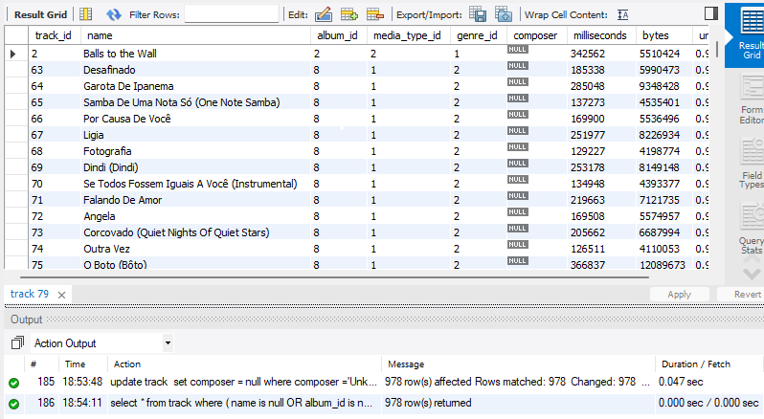

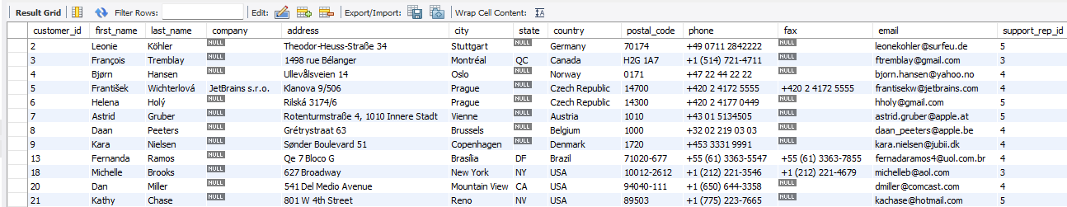
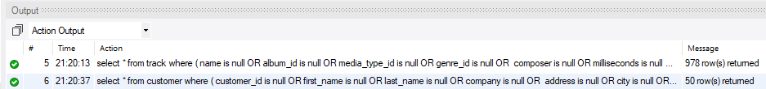

We can see that TRACK, CUSTOMER tables are having null values. We can update those null values with 'Unknown', 'No fax' because they are varchar() type.

Track table has 978 rows with nulls in composer columns. And Customer table has 50 rows with nulls in State, Company, Fax columns. So, replace it with ‘Unknown’

update track
set composer = 'Unknown'
where composer is null ;

And Customer has nulls in state, fax,

update customer
set fax='No fax'
where fax is null ;

update customer
set state='Unknown State'
where state is null;

update customer
set company='No Info'
where company is null;

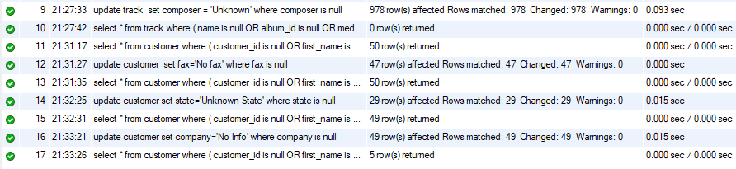

- Find the top-selling tracks and top artist in the USA and identify their most famous genres.

Top Selling tracks in USA:

select t.name as track_name, sum(invline.quantity) as total_sold,
sum(invline.quantity*invline.unit_price) as total_sales
from track t
join invoice_line invline on t.track_id=invline.track_id
join invoice inv on inv.invoice_id=invline.invoice_id
where inv.billing_country="USA" -- Customer country is same as his invoice billing country
group by 1
order by 3 desc;

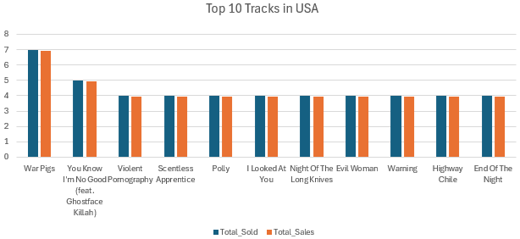

War Pigs is the best Track in the USA

Top Selling Artists in USA:

select ar.artist_id, ar.name as artist_name, sum(invline.quantity) as total_sold,
sum(invline.quantity*invline.unit_price) as total_sales
from track t
join invoice_line invline on t.track_id=invline.track_id
join invoice inv on inv.invoice_id=invline.invoice_id
join album a on a.album_id=t.album_id
join artist ar on a.artist_id=ar.artist_id
where inv.billing_country="USA"
group by 1,2
order by 4 desc ;

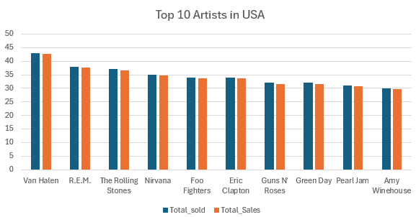

Top artist in the USA is Van Halen and his artist_id is 152.

Famous genres of the top artist in the USA:

select g.genre_id, g.name AS genre_name, sum(il.quantity) AS total_sold
from invoice i
join invoice_line il on il.invoice_id = i.invoice_id
join track t on il.track_id = t.track_id
join album al on t.album_id = al.album_id
join genre g on t.genre_id = g.genre_id
where i.billing_country = 'USA' and al.artist_id = 152
group by 1,2
order by 3 desc;

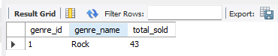

Van Halen’s only genre is Rock with a total sale of 43 in USA alone.

- What is the customer demographic breakdown (age, gender or location) of Chinook's customer base?

The given customer table has location details of customers

Based on Country:

select country, count(*) as TotalCustomers
from customer
group by country
order by 2 desc;
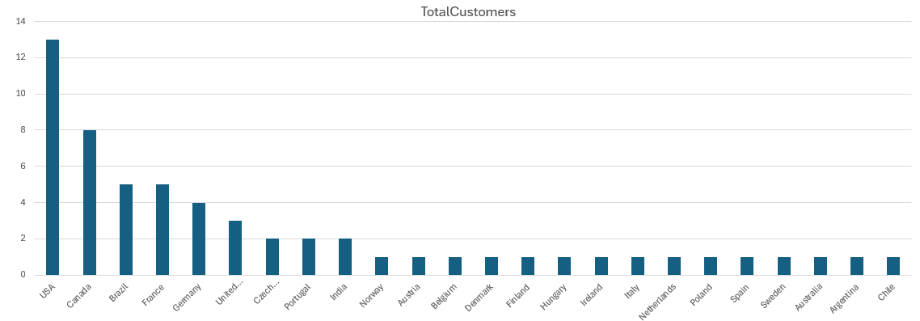

Based on States :

select state , count(*) as TotalCustomers
from customer
where state != 'Unknown State'
group by 1
order by 1,2 desc;

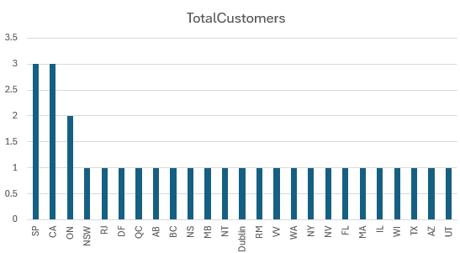

- Calculate the total revenue and number of invoices for each country, state, and city

Countries vs Total Revenue, Number of Invoices

select billing_country as country, sum(total) as total_revenue,
count(invoice_id) as total_invoices
from invoice
group by billing_country
order by total_revenue desc, total_invoices desc;

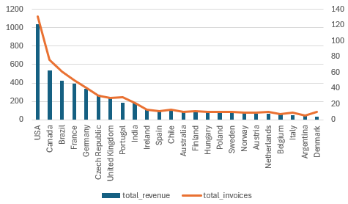

States vs Total Revenue, Number of Invoices

select billing_state as state, sum(total) as total_revenue, count(invoice_id) as total_invoices
from invoice
group by billing_state
order by total_revenue desc, total_invoices desc;

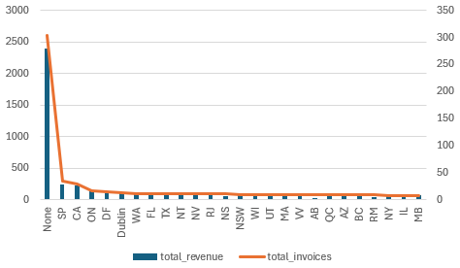

Cities vs Total Revenue, Number of Invoices:

select billing_city as city, sum(total) as total_revenue, count(invoice_id) as total_invoices
from invoice
group by billing_city
order by total_revenue desc, total_invoices desc;

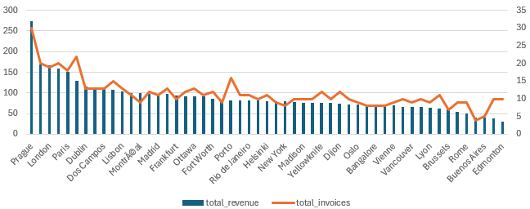

5. Find the top 5 customers by total revenue in each country

with cte as(
select c.customer_id,concat(c.first_name,' ',c.last_name) as full_name,
billing_country as country,sum(total) as total_revenue,
rank() over(partition by billing_country order by sum(total) desc) as rnk
from invoice i
join customer c on c.customer_id=i.customer_id
group by 1,2,3
order by customer_id)

select *
from cte
where rnk<=5
order by country,rnk;

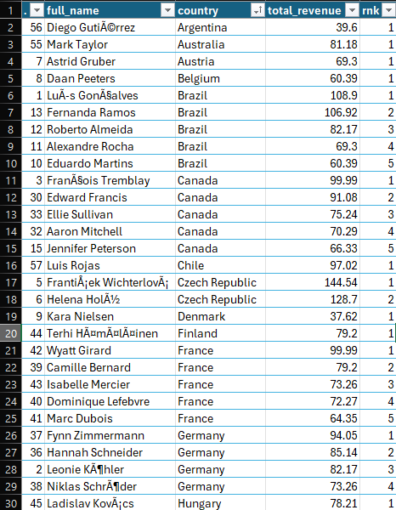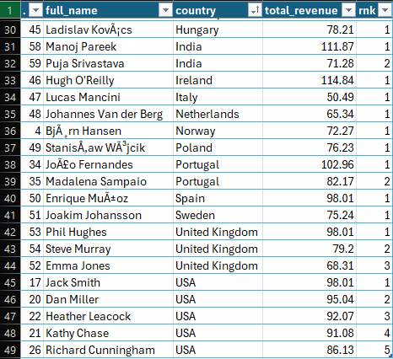

6. Identify the top-selling track for each customer

with cte as(
select c.customer_id, concat(c.first_name,’ ’,c.last_name) as full_name,
t.name AS track_name,
sum(il.quantity*il.unit_price) as total_purchased,
row_number() over (partition by i.customer_id order by sum(il.quantity*il.unit_price) desc) as rnk
from customer c
join invoice i on i.customer_id = c.customer_id
join invoice_line il on il.invoice_id = i.invoice_id
join track t on t.track_id = il.track_id
group by 1,2,3
order by 1)

select customer_id, full_name, track_name, total_purchased
from cte
where rnk=1;

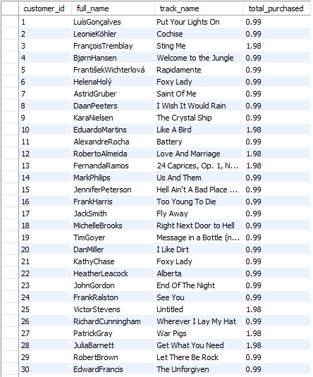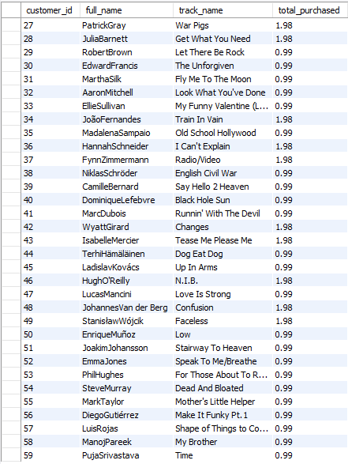

7. Are there any patterns or trends in customer purchasing behavior (e.g., frequency of purchases, preferred payment methods, average order value)?

select c.customer_id, concat(c.first_name,' ', c.last_name) as full_name,
year(i.invoice_date) as year,count(i.invoice_id) as purchase_count,
sum(i.total) as tot_revenue, avg(i.total) as avg_ord_value
from customer c
join invoice i on c.customer_id = i.customer_id
group by c.customer_id, customers, year(i.invoice_date)
order by c.customer_id, customers, year(i.invoice_date);

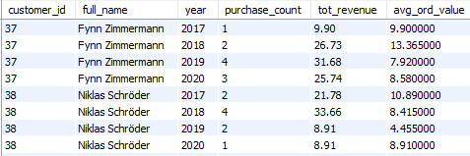

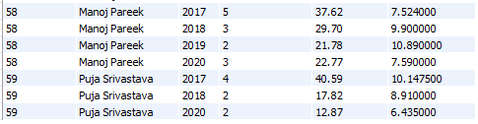

If we look at every year sales of the customers, we can see that the customer purchasing pattern of most of the customers is declining. But for few of them it Is increasing

8. What is the customer churn rate?

Churn Rate is the percentage of total customers lost in this current year

with lastyr as (
select year(max(invoice_date))-1
from invoice
),
tot_cust as (
select c.customer_id
from customer c
join invoice i on c.customer_id=i.customer_id
group by c.customer_id
having year(max(i.invoice_date)) in ( (select * from lastyr)+1,(select * from lastyr) )
),
prev_cust as (
select c.customer_id
from customer c
join invoice i on c.customer_id=i.customer_id
group by c.customer_id
having year(max(i.invoice_date)) in ((select * from lastyr))
)

select count(*)*100/(select count(*) from tot_cust) as churn_Rate
from prev_cust;

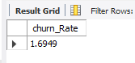

9. Calculate the percentage of total sales contributed by each genre in the USA and identify the best-selling genres and artists.

select distinct g.name,
sum(il.quantity) over w as genre_tot_sales,
( sum(il.quantity) over w *100/sum(il.quantity) over() ) as genre_perc
from invoice i
join invoice_line il on i.invoice_id=il.invoice_id
join track t on t.track_id=il.track_id
join genre g on g.genre_id=t.genre_id
where i.billing_country='USA'
window w as (partition by g.name)
order by 2 desc;

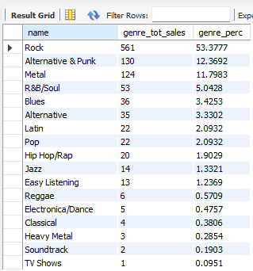

10. Find customers who have purchased tracks from at least 3 different genres

select concat(c.first_name,' ',c.last_name) as costumer_name,
count(distinct g.genre_id) as genres_purchased
from customer c
join invoice i on c.customer_id = i.customer_id
join invoice_line il on i.invoice_id = il.invoice_id
join track t on il.track_id = t.track_id
join genre g on t.genre_id = g.genre_id
group by 1
having count(distinct g.genre_id)>=3
order by 2 desc;

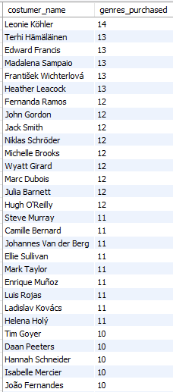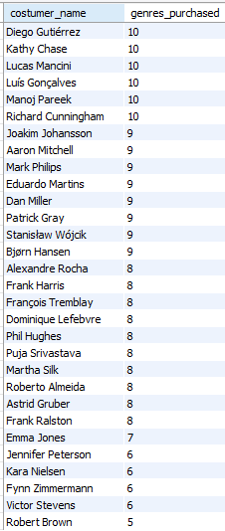

11. Rank genres based on their sales performance in the USA

select g.name, sum(il.quantity*il.unit_price) as total_revenue,
dense_rank() over ( order by sum(il.quantity) desc) as rnk
from invoice i
join invoice_line il on i.invoice_id = il.invoice_id
join track t on il.track_id = t.track_id
join genre g on t.genre_id = g.genre_id
where i.billing_country='USA'
group by g.name
order by 3;

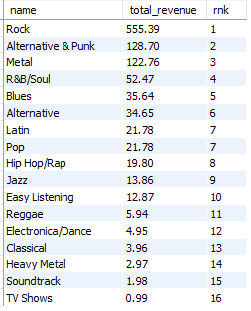

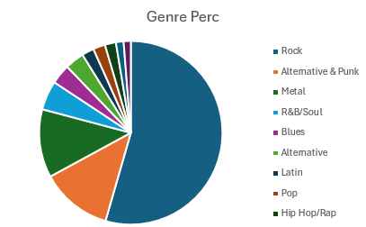

Pie Chart for Top 8 genres in USA

12. Identify customers who have not made a purchase in the last 3 months

For this let’s consider the latest invoice_date which is ‘2020-12-30’ as today date and
then we will find the customers who haven’t done a purchase in last 3 months

with latest_billday as(
select date_add( max(date(invoice_date)),interval -3 month) as recent_day
from invoice)

select distinct c.customer_id,concat(c.first_name,' ',c.last_name) as costumer_name
from customer c
join invoice i on c.customer_id=i.customer_id
group by customer_id
having max(i.invoice_date)<(select * from latest_billday)
order by 1;

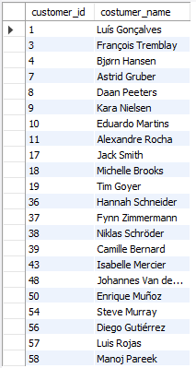

Subjective Questions

- Recommend the three albums from the new record label that should be prioritised for advertising and promotion in the USA based on genre sales analysis.

with cte as(
select g.name as genre_name, al.title as album_title,
sum(il.unit_price * il.quantity) as album_sales,dense_rank() over
(partition by g.name,al.title order by sum(il.unit_price*il.quantity) desc) rnk
from genre g
join track t on g.genre_id = t.genre_id
join invoice_line il on t.track_id = il.track_id
join invoice i on il.invoice_id = i.invoice_id
join album al on t.album_id = al.album_id
where i.billing_country = 'USA'
group by g.name, al.title
having sum(il.quantity) >4 )

select *
from cte
where rnk<=3
order by 3 desc;

Top albums based on their sales in USA

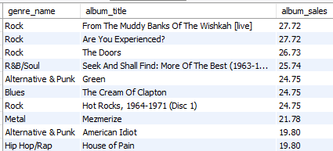

Based on the genre sales analysis, the top-performing genres in the USA are

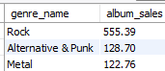

We can use these genres to do advertisement in various mediums like in TV cables,
Bill boards on highways, Radio and in social media too.

And albums from the popular genres like Rock, Alternative & punk, HipHop/Rap can be used in merchandise, concerts for promotions. And its always better to advertise diverse genres to reach diverse audiences

That doesn’t means we have to ignore the albums with less or medium sales. We use them
in location specific areas where they are famous and having great sales by maintaining a balanced strategy.

- Determine the top-selling genres in countries other than the USA and identify any commonalities or differences.

We know the top genres in USA are



Now to compare USA with other countries, we will change the billing_country in ‘WHERE’ clause to different countries to get their top genre sales.

select g.name, sum(i.total) as genre_sum,
dense_rank() over (order by sum(il.unit_price * il.quantity) desc) as rnk
from invoice i
join invoice_line il on i.invoice_id = il.invoice_id
join track t on il.track_id = t.track_id
join genre g on t.genre_id = g.genre_id
where i.billing_country = ‘India’
group by g.name ;

In India and Australia:

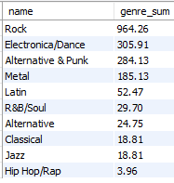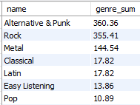

In European Countries like United Kingdom, Germany and France

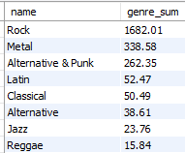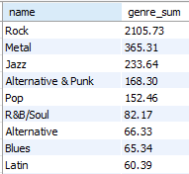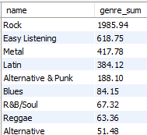

In Countries like Brazil and Canada:

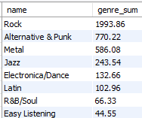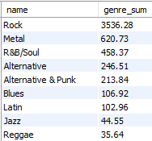

Commonalities:
- Rock, Metal, Alternative & Punk, Latin are the genres popular genres in English speaking countries like USA, UK, Australia.
- Jazz is popular in European countries. Whereas Latin is common in every country.
- And in Germany and France, genres like Latin and Reggae genres are in top 8 charts

Differences:
- In India and Brazil, we can see Electronica/Dance are popular.
- France has Easy listening genre in top 3.
- Genre Blues is famous in Canda and France.

- Customer Purchasing Behavior Analysis: How do the purchasing habits (frequency, basket size, spending amount) of long-term customers differ from those of new customers? What insights can these patterns provide about customer loyalty and retention strategies?

Lets consider customers who are buying for over a period of 1000 + days as Long term customers and others as new customers

Code:

with customer_details as (
select c.customer_id, count(distinct i.invoice_id) as tot_purchases,
sum(il.quantity) as basket_size, sum(i.total) as total_spent,
round(avg(i.total),2) as avg_order_value,
case when datediff(max(i.invoice_date), min(i.invoice_date)) >=1050
then 'long-term customers' else 'new customers' end as customer_category
from customer c
join invoice i on c.customer_id = i.customer_id
join invoice_line il on i.invoice_id = il.invoice_id
group by c.customer_id
)

select customer_category, round(avg(tot_purchases),2) as avg_purchase_frequency,
round(avg(basket_size),2) as avg_basket_size,
round(avg(total_spent),2) as avg_spending_amount,
round(avg(avg_order_value),2) as avg_order_value
from customer_details
group by customer_category;

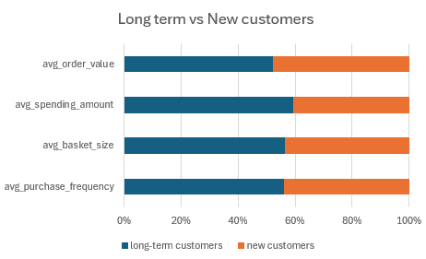

Insights from the Data:
- Long-term customers purchase more frequently (10.64 vs. 8.33), have larger basket sizes (82.55 vs. 63.67), and spend more (831.92 vs. 568.59) when compared to new customers.
- New customers show lower spending and engagement, indicating growth potential.
- It means that the Long-term customers have very good trust on the store. And store
can make it happen in new customers also.

Customer Loyalty and Retention Strategies:
- Launch some special offers and gifts for long-term customers for their trust on the store.
- Offer yearlong discounts to customers if they subscribe to the store yearly plan
- Encourage larger basket sizes and suggest complementary products and discounts.
- Plan rewarding customers for bringing in new buyers like referral programs.

- Product Affinity Analysis: Which music genres, artists, or albums are frequently purchased together by customers? How can this information guide product recommendations and cross-selling initiatives?

Product Affinity Analysis:

Genre Affinity Analysis:

Let’s look at the Genres which are purchased together mostly

select distinct g1.name as genre01, g2.name as genre02,
count(distinct il1.invoice_id) as combined_purchase_count
from invoice_line il1
join invoice_line il2 on il1.invoice_id = il2.invoice_id and il1.track_id < il2.track_id
join track t1 on il1.track_id = t1.track_id
join track t2 on il2.track_id = t2.track_id
join genre g1 on t1.genre_id = g1.genre_id
join genre g2 on t2.genre_id = g2.genre_id where g1.genre_id < g2.genre_id
group by 1,2
order by 3 desc ;

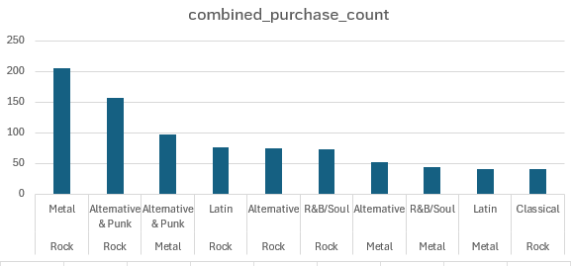

- Rock-Metal (206) and Rock-Alternative & Punk (157) are the top-performing genre pairs, showing strong audience overlap.
- By keeping rock and metal as central genre, and then pairing them effectively with diverse genres like Alternative & punk, Latin, and Classical can bring high sales.
- And using personalized recommendations like “customers who also have bought this “
- to suggest related genres to customers.
- Promoting multi-genre playlists and genre-pair concerts can also bring sales

Artist Affinity Analysis:

Let’s look at the Artists whose albums are purchased together mostly

select distinct ar1.name as artist01, ar2.name as artist02,
count( distinct il1.invoice_id ) as combined_purchase_count
from invoice_line il1
join invoice_line il2 on il1.invoice_id = il2.invoice_id and il1.track_id < il2.track_id
join track t1 on il1.track_id = t1.track_id
join track t2 on il2.track_id = t2.track_id
join album a1 on t1.album_id = a1.album_id
join album a2 on t2.album_id = a2.album_id
join artist ar1 on a1.artist_id = ar1.artist_id
join artist ar2 on a2.artist_id = ar2.artist_id and ar1.artist_id <> ar2.artist_id
group by 1,2
order by 3 desc ;

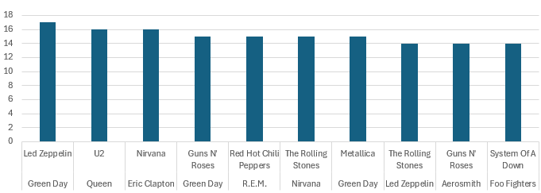

- Green Day and Led Zeppelin have the highest combined purchase count of 17.
- And pairs like Queen, U2 and Eric Clapton, Nirvana are also popular combinations.
- Artists like Green Day, Nirvana, Guns N Roses, The Rolling Stones and Led Zepplin can be used in artist combos to get more sales
- Pair up the artists and provide Bundle offers and Combo offers.
- And give lucky draws, merchandise toattract more customers

Album Affinity Analysis:

Let’s look at the albums which are purchased together mostly

select distinct a1.title as album01, a2.title as album02,
count( distinct il1.invoice_id ) as combined_purchase_count
from invoice_line il1
join invoice_line il2 on il1.invoice_id = il2.invoice_id and il1.track_id < il2.track_id
join track t1 on il1.track_id = t1.track_id
join track t2 on il2.track_id = t2.track_id
join album a1 on t1.album_id = a1.album_id
join album a2 on t2.album_id = a2.album_id where a1.album_id <> a2.album_id
group by 1,2
order by 3 desc ;

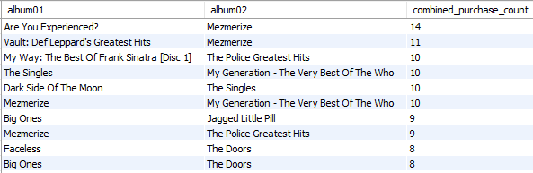

- Mezmerize and Are you experienced are the most purchased together album combo.
- Pairs like The singles, My generation and Dark side of the moon, the singles are also the popular combos
- My generation, The Doors, Memorize, Big ones are central album by combining them with other albums like a combo playlist can bring more sales.

- Regional Market Analysis: Do customer purchasing behaviors and churn rates vary across different geographic regions or store locations? How might these correlate with local demographic or economic factors?

We can divide the whole customers into 3 sectors based on how many times they bought music from the music store over the years.

They are: Low Values customers (with < 70 purchases),
Mid valued customers (with btw 70 and 90 purchases),
High valued customers (with > 90 purchases )

Let’s count the type of customers in every country to do market analysis based on location:

select a.country,count(a.customer_id) as high_valued_customers
from customer a
join ( select (customer_id),count(quantity) as high_valued_customers
from invoice i
join invoice_line il on i.invoice_id = il.invoice_id
group by customer_id
having count(quantity) > 90 ) b on a.customer_id=b.customer_id
group by 1
order by 2 desc;

After running their respective codes, we can say that

  - Most number of High valued customers are in USA, Brazil, Canada, Czech Republic.
  - Most number of Mid valued customers are in USA, Canada, France, Brazil, Germany.
  - Most number of Low valued customers are in Italy, Argentina, Denmark.
  - And Countries like USA, Canada have all kind of customers
  - Brazil, France, Germany have both high and mid values customers.

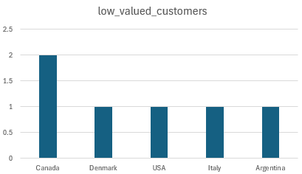

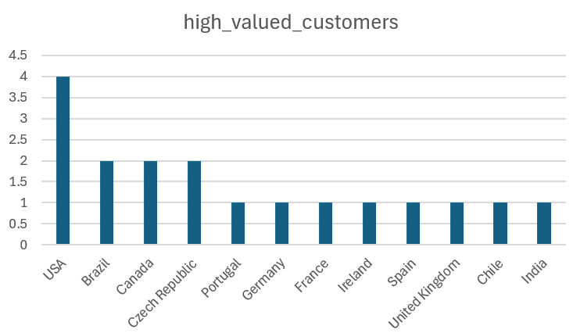

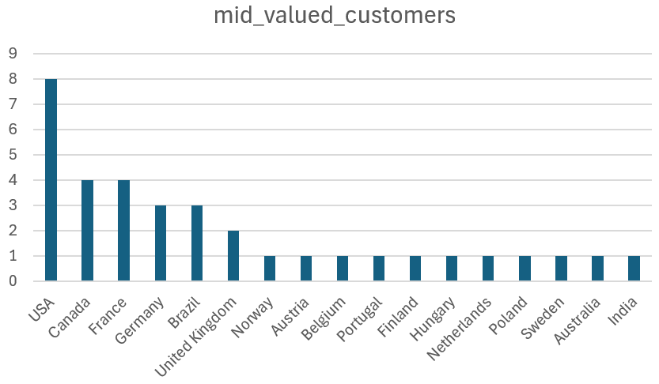

Correlation between customer purchasing behaviors and local demographic or economic factors:

- Countries with higher GDP per capita and disposable income (e.g., Canada, Ireland, and France) tend to have customers who spend more on entertainment like music.
- Countries with a rich music culture and a strong preference for both local and international music (e.g., Brazil, France, and India), customers are more engaged and likely to purchase music.
- Countries with a more mature digital economy and e-commerce infrastructure (e.g., Ireland, Czech Republic, and Portugal) provide an environment conducive to higher online spending on music.
- Countries with higher GDP per capita and disposable income (e.g., Canada, Ireland, and France) tend to have customers who spend more on entertainment

- Customer Risk Profiling: Bas ed on customer profiles (age, gender, location, purchase history), which customer segments are more likely to churn or pose a higher risk of reduced spending? What factors contribute to this risk?

As of the given data, there is no info available on the customers location, age. And the only parameter, we can consider segment them is again the demographics of the customer and then further classify them based on the state and its location.

We can divide the whole customers into 3 sectors based on how many times they bought music from the music store over the years.

They are: Low Values customers (with < 70 purchases),
Mid valued customers (with btw 70 and 90 purchases),
High valued customers (with > 90 purchases )

Let’s count the type of customers in every country to do market analysis based on location to know about the churn rate in all the countries

select a.country,count(a.customer_id) as mid_valued_customers
from customer a
join ( select (customer_id),count(quantity) as high_valued_customers
from invoice i
join invoice_line il on i.invoice_id = il.invoice_id
group by customer_id
having count(quantity) between 70 and 90 ) b on a.customer_id=b.customer_id
group by 1
order by 2 desc;



- The above charts show the demographics of the low valued customers location.
- The customers from these locations have purchased the least and are most likely to churn.
- So, we need to run Ad campaigns to increase customers in such areas.
- And it does meant to leave the high values customers, we have to continue to have their trust by giving discounts and products what they like most and needed most.

- Customer Lifetime Value Modeling: How can you leverage customer data (tenure, purchase history, engagement) to predict the lifetime value of different customer segments? This could inform targeted marketing and loyalty program strategies. Can you observe any common characteristics or purchase patterns among customers who have stopped purchasing?

Customer data such as tenure, purchase history and engagement are very helpful to predict the lifetime value of different customer segments

And to leverage the customer data and predict customer lifetime value and identifying patterns among customers who have stopped purchasing. The following are the steps that needs to be looked into:

- Tenure: It helps to calculate the duration of the customer relationship to identify common characteristics and patterns among customers.

Lets consider customers who are buying for over a period of 1000 + days as “Long term customers” and others as “New customers”

By dividing customers in that way, we can calculate average order value, average spending, average basket size and average purchase frequency. As below



- Purchase History and Engagement: Total revenue and Purchase frequency of the customers helps in understanding their purchasing history and their engagement with the music store.

Below code gives the purchase count/frequency and total revenue of few customers

select c.customer_id, concat(c.first_name,' ', c.last_name) as full_name,
count(i.invoice_id) as purchase_count, sum(i.total) as tot_revenue, avg(i.total) as avg_ord_value
from customer c
join invoice i on c.customer_id = i.customer_id
group by c.customer_id, full_name
order by 3 desc, 4 desc

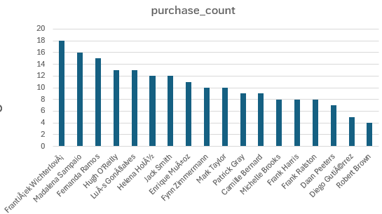

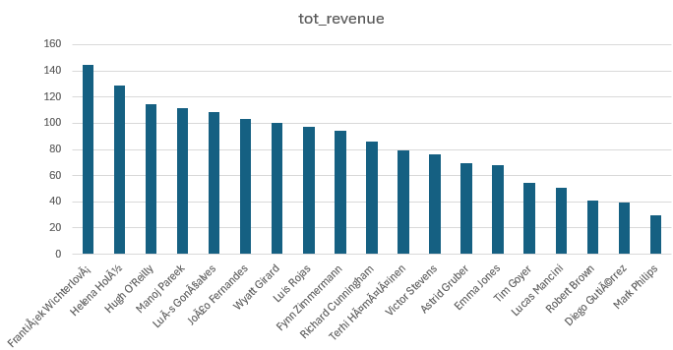

- Churn rate: Calculate the time since the last purchase for each customer.

By considering year in the latest invoice as the current year. We can find the customers who haven’t done any purchase in current year.
After doing this we can find only one customer who haven’t done any purchase from the store in this year and he’s from Belgium. We can’t do any analysis with one customer.

with curr_year as (
select year(max(invoice_date))
from invoice
),

lost_cust as (
select c.customer_id, concat(c.first_name,' ',c.last_name) as customer_name,
c.country, date(max(i.invoice_Date)) as last_date
from customer c
join invoice i on c.customer_id=i.customer_id
group by c.customer_id
having year(max(i.invoice_date)) <> ((select * from curr_year))
)

select *
from lost_cust

Above code gives detaila of the customers we lost.

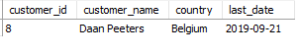

- If data on promotional campaigns (discounts, events, email marketing) is available, how could you measure their impact on customer acquisition, retention, and overall sales?

We currently do not have direct access to data on promotional campaigns, such as discounts, events, or email marketing. However, if this data were available, we could evaluate the impact of these campaigns on customer acquisition, retention, and overall sales using the following method:

Method for Evaluating Impact:

- Determine Promotion Timeframes: Use a data source or field that logs the dates or periods when promotions were conducted.

- Separate Data Sets: Divide the data into two categories: periods with promotions and periods without promotions.

- Measure Customer Acquisition:Compare the number of new customers gained during promotional periods against those gained during non-promotional periods.

- Assess Customer Retention:Analyze repeat purchase rates to evaluate customer retention during and following promotional periods.

- Compare Sales Metrics: Examine metrics such as total sales, average order value, and basket size for promotional periods compared to non-promotional periods.

This method would help us understand the effectiveness of promotional efforts in achieving desired business objectives.

- How would you approach this problem, if the objective and subjective questions weren't given?

If no predefined questions are provided, the following approach involves a systematic, exploratory analysis of the available data:

Steps for Exploratory Data Analysis

- Review Data Structure: Identify key entities and relationships (e.g., Employee, Customer, Invoice).Determine critical metrics such as sales performance and customer demographics.
- Perform Data Exploration and Quality Check: Check for missing values, duplicates, and inconsistencies. Clean the data by imputing missing values or removing incomplete records.
- Analyze Sales Performance: Examine total sales, average order value, and top-selling products across different time periods, regions, and customer segments.
- Conduct Customer Analysis: Analyze customer demographics and segment customers based on purchase history.Calculate churn rates and estimate Customer Lifetime Value (CLV).
- Evaluate Market and Regional Trends: Assess sales performance across different regions and correlate with external factors, such as local demographics.
- Identify Product Affinity and Cross-Selling Opportunities: Detect frequently purchased product combinations to identify cross-selling opportunities.
- Analyze Promotional Effectiveness: Measure the impact of promotional activities on sales and customer behavior.
- Develop Strategic Insights: Identify growth opportunities, refine pricing strategies, and design targeted marketing plans.
- Document and Report Findings: Summarize insights with visualizations and provide actionable recommendations.
- Conclusion: This approach involves a thorough exploration of data to uncover insights that can guide strategic decisions, improve customer retention, optimize sales, and identify growth opportunities. The process is iterative and continually evolves as new insights emerge.

- How can you alter the "Albums" table to add a new column named "ReleaseYear" of type INTEGER to store the release year of each album?

We can change table schema with DDL commands like Alter, Create, Drop.
And with Alter table we can add, modify, remove any column of a table

Code:

alter table album
add column releaseyear integer;

Checking the table:

select * from album;

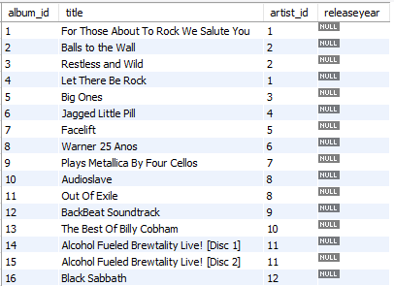

We can see a new coloumn named releaseyear is added to the album table.

- Chinook is interested in understanding the purchasing behavior of customers based on their geographical location. They want to know the average total amount spent by customers from each country, along with the number of customers and the average number of tracks purchased per customer. Write an SQL query to provide this information.

with customer_details as(
select c.country, c.customer_id, sum(il.quantity) as total_tracks,
sum(i.total) as total_spent, sum(il.quantity*il.unit_price) as spent2
from customer c
join invoice i on c.customer_id = i.customer_id
join invoice_line il on i.invoice_id = il.invoice_id
group by 1,2)

select Country, count(customer_id) as tot_customers,
avg(total_tracks) as avg_tracks_purchased_per_cust,
avg(spent2) as avg_amnt_spent_per_customer
from customer_details
group by 1
order by 2 desc

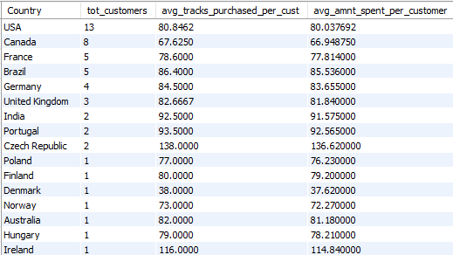

- Most of the European Countries like Denmark, Itlay, Poland, Ireland, Belgium have one customer for each country.
- And North America (USA, Canada) has most customers than other countries
- Even with less customers both Czech Republic and Ireland has one of the highest records in average tracks purchased and average amount spent per customer.

